SUPPLEMENTAL APPENDIX

Table SA.1: Demographic Information for White Democrats and White Republicans by Treatment Types
 | Republican Racial Treatment
 | White Candidate |  |  | Black Election |  |  | Latino Treatment
 | N | Mean | Std. Dev. | Obs | Mean | Std. Dev. | Obs | Mean | Std. Dev.
Female (Percent) | 52 | 0.48 | 0.50 | 53 | 0.38 | 0.49 | 42 | 0.40 | 0.50
Age (In Years) | 49 | 38.73 | 11.12 | 53 | 38.47 | 12.89 | 40 | 38.88 | 12.11
Income (In 1000's) | 51 | 75.58 | 44.61 | 53 | 65.84 | 42.65 | 42 | 70.11 | 36.93
Education (In Years) | 50 | 15.08 | 1.82 | 53 | 15.25 | 1.72 | 42 | 15.00 | 1.94
South (Percent) | 52 | 0.37 | 0.49 | 53 | 0.32 | 0.47 | 42 | 0.31 | 0.47
 | Republican Religious Treatment
 | White Candidate |  |  | Black Election |  |  | Latino Treatment
Female (Percent) | 65 | 0.48 | 0.50 | 65 | 0.46 | 0.50 | 75 | 0.45 | 0.50
Age (In Years) | 65 | 37.74 | 14.10 | 65 | 38.43 | 12.89 | 75 | 39.44 | 13.32
Income (In 1000's) | 65 | 62.14 | 40.41 | 64 | 64.83 | 39.97 | 75 | 62.86 | 38.52
Education (In Years) | 64 | 14.94 | 1.71 | 65 | 15.14 | 1.84 | 75 | 14.99 | 1.81
South (Percent) | 65 | 0.31 | 0.47 | 65 | 0.35 | 0.48 | 75 | 0.33 | 0.47
 | Democrat Racial Treatment
 | White Candidate |  |  | Black Election |  |  | Latino Treatment
Female (Percent) | 81 | 0.46 | 0.50 | 83 | 0.53 | 0.50 | 78 | 0.58 | 0.50
Age (In Years) | 77 | 34.87 | 12.76 | 82 | 36.50 | 11.57 | 78 | 37.19 | 12.61
Income (In 1000's) | 80 | 51.74 | 36.11 | 82 | 58.47 | 40.74 | 76 | 57.69 | 42.14
Education (In Years) | 81 | 14.79 | 1.92 | 81 | 15.09 | 1.98 | 77 | 15.35 | 1.73
South (Percent) | 81 | 0.35 | 0.48 | 83 | 0.31 | 0.47 | 78 | 0.29 | 0.46
 | Democrat Religious Treatment
 | White Candidate |  |  | Black Election |  |  | Latino Treatment
Female (Percent) | 92 | 0.55 | 0.50 | 102 | 0.44 | 0.50 | 82 | 0.46 | 0.50
Age (In Years) | 92 | 35.51 | 11.73 | 100 | 35.11 | 10.79 | 83 | 35.46 | 11.81
Income (In 1000's) | 88 | 62.09 | 39.43 | 102 | 63.32 | 42.28 | 80 | 56.55 | 41.37
Education (In Years) | 92 | 15.20 | 1.63 | 103 | 15.30 | 1.81 | 83 | 14.94 | 1.78
South (Percent) | 92 | 0.25 | 0.44 | 103 | 0.30 | 0.46 | 83 | 0.30 | 0.46

Table SA. 2 OLS Regression Predicting Black Democrats Attitudes towards Black Racial Resentment Scores (A) and Latino Racial Resentment (B). Note: There Were Two Few Black Republicans to Estimate a Meaningful Analysis
 | A | B
 | Black Democrats | Black Democrats
 | Race Resent  Black | Race Resent  Latino
Racial Prej Treatment*Black Candidate | -1.02 | -0.20
 | (1.14) | (0.90)
Racial Prej Treatment*Latino Candidate | -1.26 | 0.82
 | (1.24) | (0.98)
Racial Prej Treatment | 0.95 | -0.75
 | (0.83) | (0.65)
Black Candidate | 0.67 | 0.62
 | (0.76) | (0.60)
Latino Candidate | 1.45 | -0.74
 | (0.92) | (0.73)
Female | 0.33 | 0.20
 | (0.51) | (0.40)
Age | -0.04* | -0.00
 | (0.02) | (0.02)
Income | 0.00 | -0.01
 | (0.01) | (0.01)
Education | -0.16 | 0.28**
 | (0.17) | (0.13)
South | -0.29 | -0.13
 | (0.49) | (0.38)
Constant | 11.47*** | 4.14**
 | (2.35) | (1.85)
Observations | 72 | 72
R-squared | 0.15 | 0.19
Note: *** p<0.01, ** p<0.05, * p<0.1 Standard Error in Parentheses.

Table SA. 3 OLS Regression Predicting Latino Democrats Attitudes towards Black Racial Resentment Scores (A) and Latino Racial Resentment (B). Note: There Were Two Few Latno Republicans to Estimate a Meaningful Analysis
 | A | B
 | Latino  Democrats | Latino  Democrats
 | Race Resent  Black | Race Resent  Latino
Racial Prej Treatment*Black Candidate | -4.54 | 0.50
 | (2.77) | (1.66)
Racial Prej Treatment*Latino Candidate | 0.20 | 0.97
 | (2.16) | (1.29)
Racial Prej Treatment | 1.06 | -0.16
 | (1.61) | (0.96)
Black Candidate | 1.41 | -0.41
 | (1.58) | (0.95)
Latino Candidate | -0.64 | -0.55
 | (1.54) | (0.92)
Female | 0.10 | -0.84
 | (0.93) | (0.56)
Age | 0.07 | 0.01
 | (0.05) | (0.03)
Income | -0.01 | -0.00
 | (0.01) | (0.01)
Education | -0.38 | 0.06
 | (0.29) | (0.17)
South | 1.02 | -0.24
 | (0.97) | (0.58)
Constant | 12.59*** | 7.54***
 | (4.05) | (2.43)
Observations | 42 | 42
R-squared | 0.17 | 0.11
Note: *** p<0.01, ** p<0.05, * p<0.1 Standard Error in Parentheses.

Article Treatments: Democratic Religious Treatment
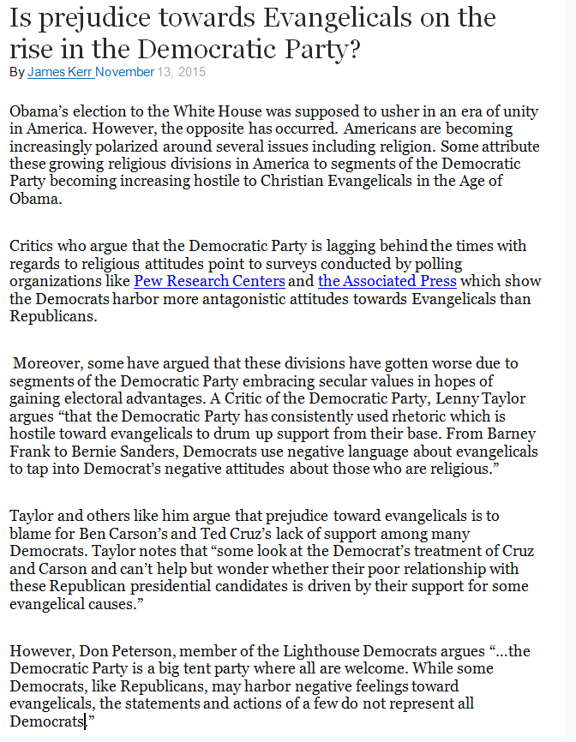
Article Treatments: Democratic Racial Treatment
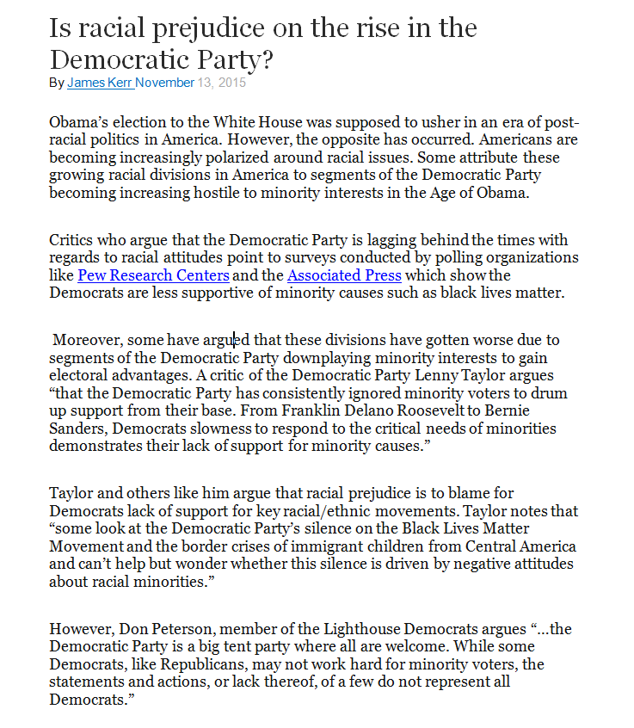

Article Treatments: Republican Religious Treatment
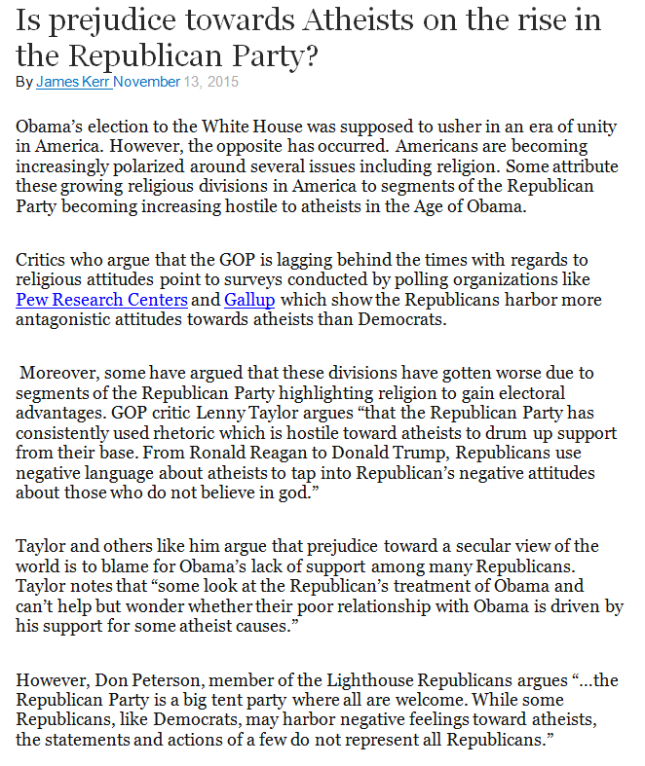

Article Treatments: Republican Racial Treatment

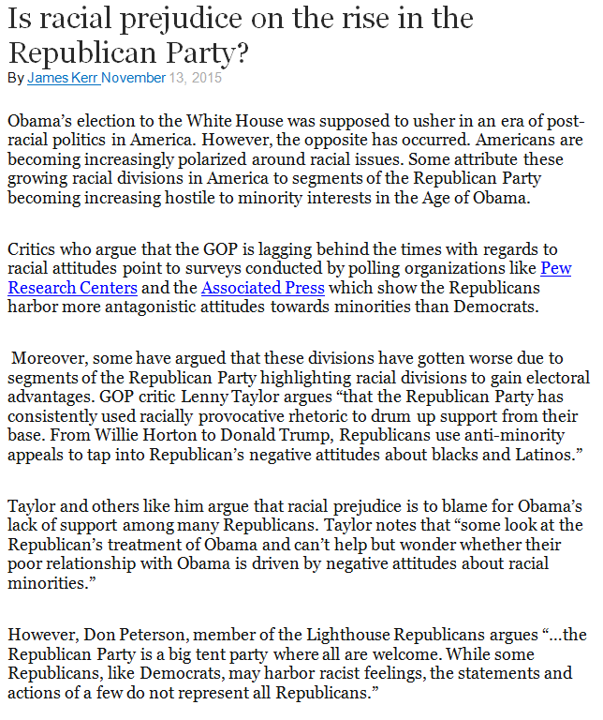

The articles were based off of the following real world articles…

https://www.washingtonpost.com/news/wonk/wp/2014/04/14/data-suggest-republicans-have-a-race-problem/

http://bigstory.ap.org/article/ap-poll-majority-harbor-prejudice-against-blacks

http://www.pewforum.org/2014/07/16/how-americans-feel-about-religious-groups/

Election Treatment: Democratic 2 White Candidate Treatments

Election Treatment: Democratic Black Candidate Treatment

Election Treatment: Democratic Latino Candidate Treatment
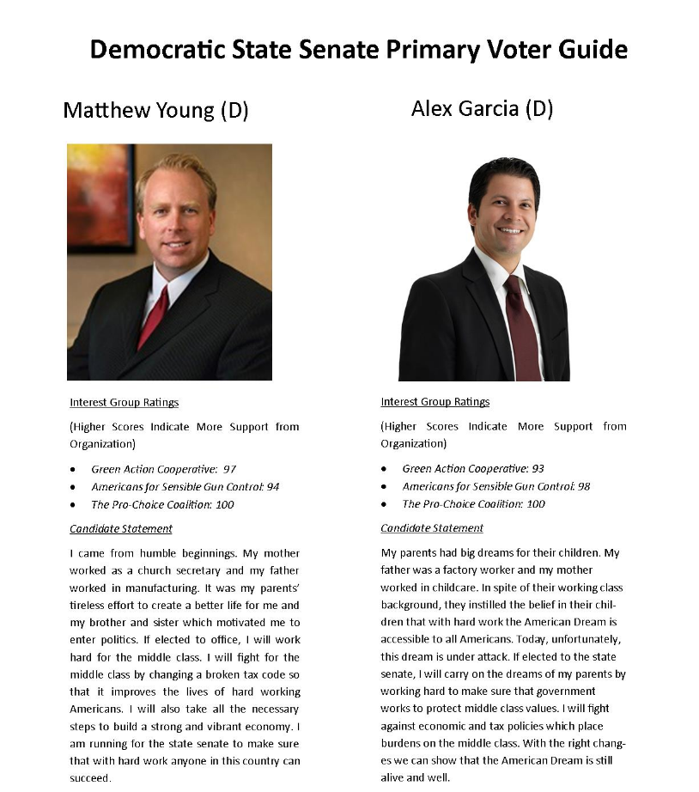

Election Treatment: Republican 2 White Candidate Treatments

Election Treatment: Republican Black Candidate Treatment
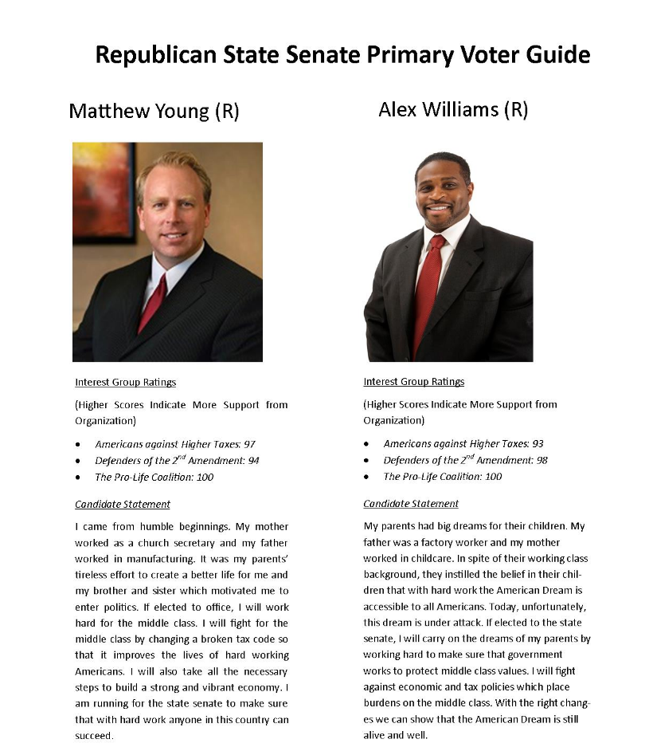

Election Treatment: Republican Latino Candidate Treatment

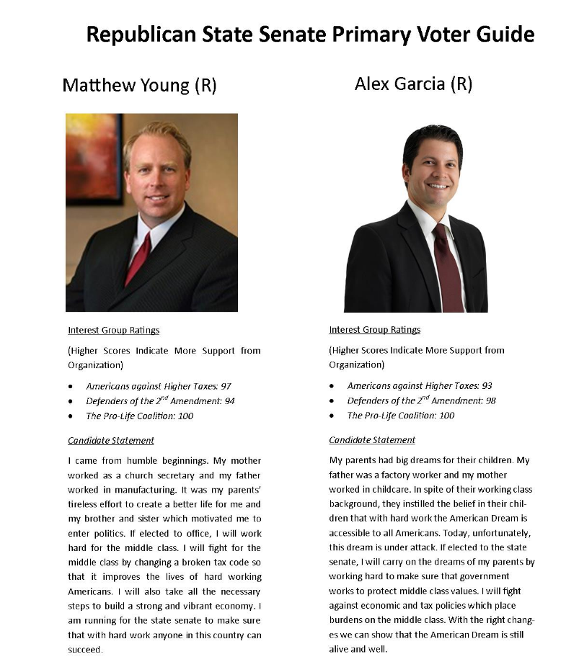

Figure 1: Average White Republican and Democrat Levels Black Racial Resentment (A & B), and Latino Racial Resentment (C & D) by Treatment Types
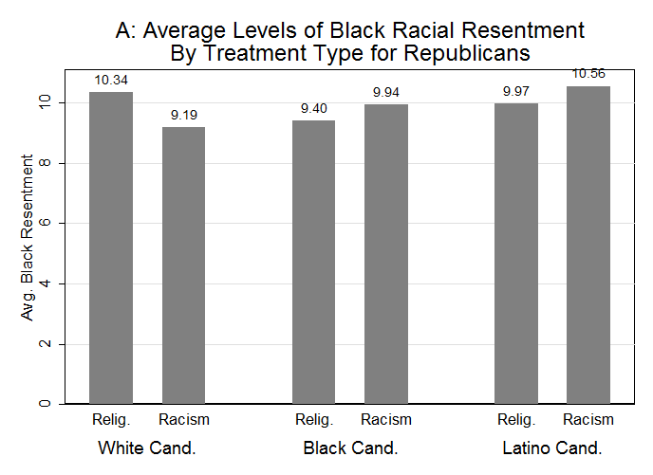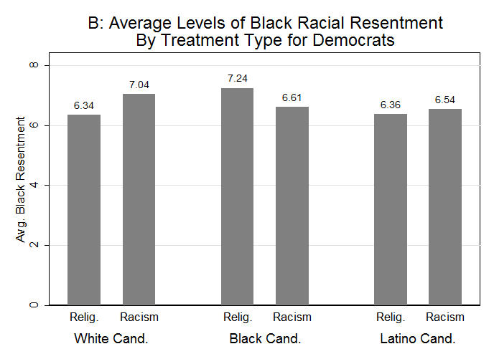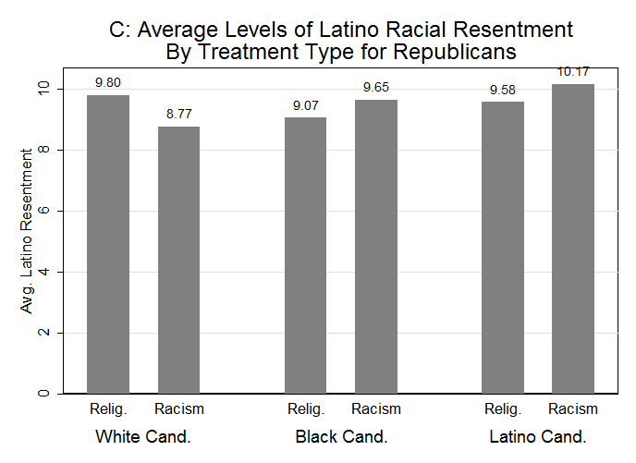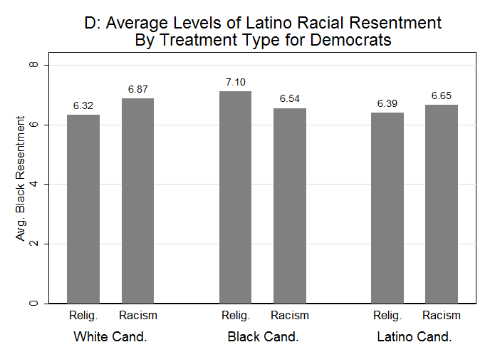
Note: Republican Racial Treatment –(White Candidate=52, Black Candidate=53, Latino Candidate=42), Republican Religious Treatment –(White Candidate=65, Black Candidate=65, Latino Candidate=75), Democratic Racial Treatment –(White Candidate=81, Black Candidate=83, Latino Candidate=75), Republican Religious Treatment –(White Candidate=92, Black Candidate=102, Latino Candidate=83)-Y-AXIS SCALE DIFFERS BY PARTISANSHIP

Figure 1 presents the results of 4 separate histograms exploring differences in whites’ black (1A- Republicans Only, 1B-Democrats Only) and Latino racial resentment scores (1C-Republicans Only, 1D Democrats Only) among individuals who read the religious vs. the racial prejudice article. These histograms are further disaggregated by the race of the hypothetical state senate candidate Alex Williams/Garcia whose race varied from being white, to being black, to being Latino. The racial resentment measures presented in Figure 1 range from 3 (low racial resentment) to 15 (high racial resentment).
The results in Figure 1 provide strong support for our three hypotheses. Republicans were significantly more likely to respond to claims that their party harbors racial prejudice by demonstrating lower levels of racial resentment toward blacks and Latinos. For example, according to Figure 1A, white Republicans who had the opportunity to select among two white male candidates and read the racial prejudice article had a 1.15 point lower black racial resentment score (on a fifteen point scale) than those in the same election treatment group who read the religious prejudice article. This difference was statistically significant at .05 according to a t-test (p=.03). Similarly, white Republicans in the two white candidate election treatment who read the racial prejudice article had about a 1 point lower score on the Latino racial resentment scale than comparable individuals who read the religious prejudice article. This difference was also statistically significant (p=.05). Taken together, claims of racial prejudice within the Republican Party decrease white Republican’s stated levels of black and Latino racial resentment.
However, the effect that claims of racial prejudice have on racial resentment disappear when there is at least one minority candidate on the ballot according to the results in Figures 1A and 1C. When white Republicans are told that their party holds negative racial attitudes and are presented with an election with at least one minority candidate, they are not significantly different from their counterparts in the same election context who read about religious prejudice in their levels of black (p_{black candidate}=.30, p_{Latino candidate}=.23) or Latino racial resentment (p_{blackcandidate}=.25, p_{latinocandidate}=.24) This result provides support for our second hypothesis that attitudes about race amongst Republicans shift when they are told their party holds racial prejudices, but this shift is abated if there are minority candidates on the ballot.
Figures 1B and 1D demonstrate that regardless of the presence of a minority candidate in a state senate election, white Democrat’s levels of racial resentment did not decline when they were presented with evidence that their party holds racial prejudice. A t-test indicated that there were no significant differences in levels of black racial resentment when individuals are given the racial versus the religious prejudice treatment and were presented two white candidates (p = 0.11), one black candidate (p=.12), or one latino candidate (p=.68). Similarly, white Democrats who were confronted with claims of racial prejudice did not have higher levels of Latino racial resentment than those presented with accusations of religious prejudice regardless of the race/ethnicity of Alex Williams/Garcia (p_{white candidate}=.18, p_{black candidate}=.16, p_{Latino candidate}=.55). Regardless of the race of the candidate representing their party in the election, white Democrats did not appear to respond to accusations of racism. This is consistent with our third hypothesis that claims of racial prejudice would only influence Republicans’ racial attitudes.

